VPC NOTES:

Create VPC through wizard 1 with one public subnet:

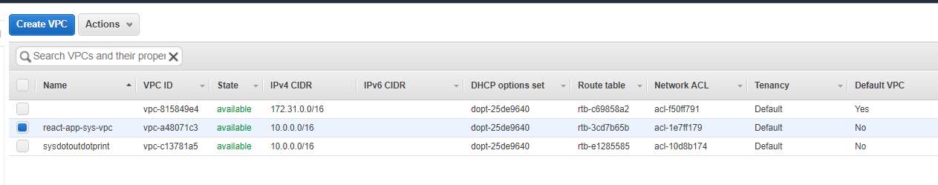

Check your route table,

Make sure you have at least a internet gateway, this allows the machine to connect to the internet

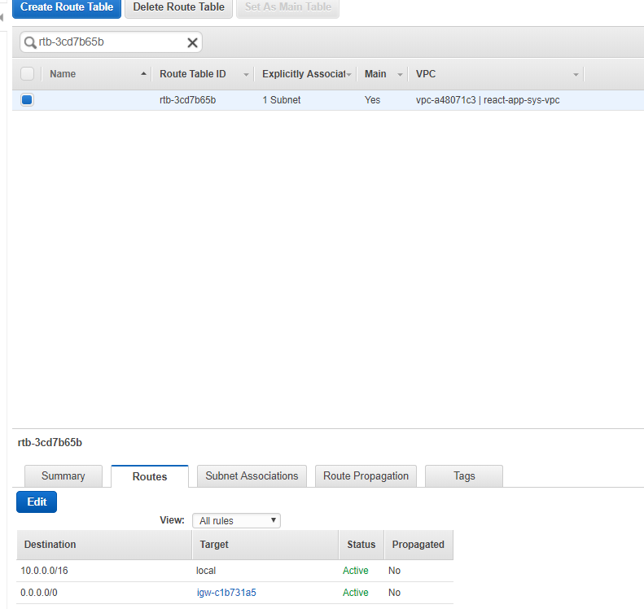

Subnet associations:

Have at least 1 public subnet associated

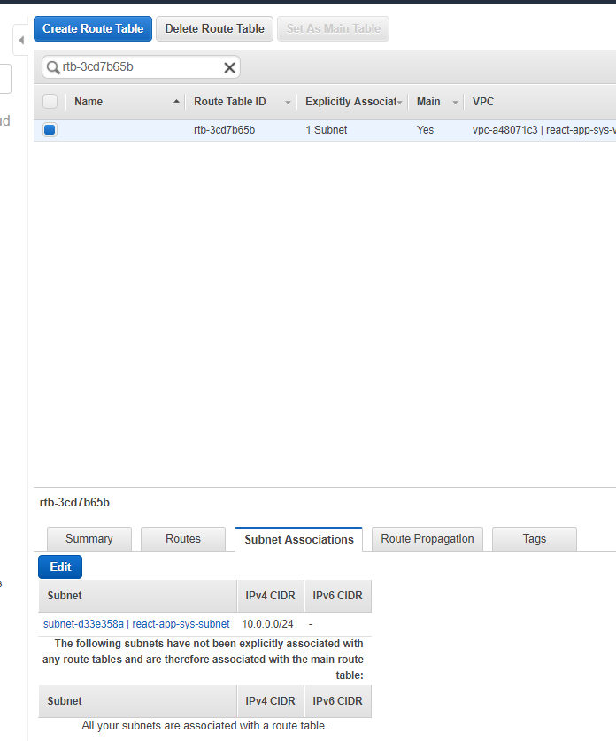

NETWORK ACL

Controls internal layer of traffic:

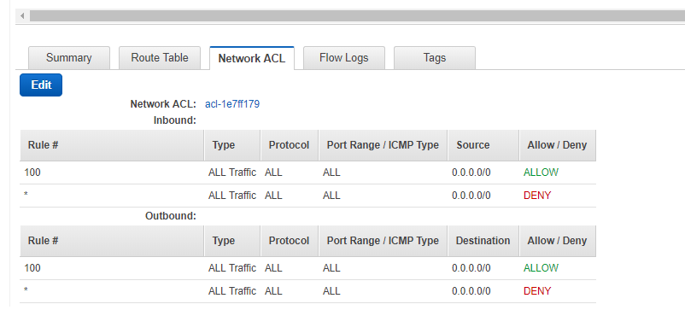

Check your inboud outbound in security group for your ec2

